Food Safety Inspections Analysis
1. Introduction
Food safety plays a pivotal role in maintaining public health, especially in densely populated urban regions where thousands of food establishments operate under government regulation. Regular inspections are conducted to ensure that restaurants and other food-serving facilities comply with hygiene standards, safety procedures, and legal health codes. The dataset used in this project originates from two major U.S. cities: Chicago and Dallas. Each city collects and shares its inspection data publicly, but with distinct schemas, violation formats, and reporting systems. These inspections, conducted by public health departments, play a critical role in ensuring that food establishments comply with hygiene, safety, and operational standards.
- Chicago data is sourced from the City of Chicago Open Data Portal.
- Dallas data is retrieved from the Dallas Open Data Portal.
Both datasets differ significantly in structure, schema, and violation reporting styles, necessitating custom transformation workflows. This project unifies, cleans, models, and visualizes these datasets using modern data engineering practices, following the Medallion Architecture (Bronze → Silver → Gold).
The primary goal of this project is to clean, analyze, and integrate these city-specific datasets into a unified data warehouse model using modern data engineering principles. The project adheres to the Medallion Architecture, consisting of Bronze (raw data), Silver (cleaned/curated), and Gold (analytically modeled) layers. Technologies employed include Databricks, Snowflake, Alteryx, and Tableau/Power BI for dashboarding.

2. Dataset Overview
Dallas (2021–Present)
- Shape: 47,219 rows × 114 columns
- Format: Wide format – each violation is a separate set of 4 columns (description, points, detail, memo) repeated up to 25 times.
- Key Columns:
  - Restaurant Name, Inspection Type, Inspection Date, Inspection Score
  - Address components: Street Number, Street Name, etc.
  - Violation Description - 1 to Violation Description - 25
  - Lat Long Location (in address + coordinates format)

Chicago (2021–Present)
- Shape: 130,462 rows × 17 columns
- Format: Long format – all violations are within a single Violations column as free-text strings.
- Key Columns:
  - DBA Name, License #, Facility Type, Risk, Inspection Type, Inspection Date, Results
  - Violations: concatenated string of violations (e.g., "3. MANAGEMENT... | 5. CLEANLINESS...")
  - Latitude, Longitude (separate columns)

Aspect | Dallas | Chicago
Structure | Wide – one row per inspection, violations unpivoted | Long – one row per inspection, violations concatenated
Cleaning Required | Need to unpivot violations | Need to split and parse violations
Geographic Info | Combined as a string in Lat Long Location | Separate in Latitude, Longitude
Risk Assessment | Not available | Present as Risk 1, Risk 2, Risk 3
Inspection Outcome | Inspection Score | Results (Pass/Fail/etc.)

3. Profiling
Data profiling is essential to assess the health and usability of raw datasets. Profiling was conducted using Alteryx, pandas profiling (ydata-profiling), and Databricks notebook inspections.
3.1 Metrics Captured
- Null values
- Data type mismatches (e.g., Zip Code as float)
- High-cardinality fields (e.g., Facility Name)
- Unique value distributions
- Format inconsistencies in dates, results, and violation codes
3.2 Observations
- Dallas dataset had high sparsity beyond Violation 1 to Violation 5
- Many zip codes were stored as floats, which required standardization
- Chicago's violation column contained mixed-format violation texts
- Address components in Dallas needed merging

File | City | Rows | Columns | Max % Missing in Any Column | Total Nulls | Avg Nulls/Row | High Null Columns (>30%)
Dallas_2021-2022.tsv | Dallas | 17,586 | 114 | 99.99% | 1,451,839 | 82.56 | Street Direction, Street Unit, Violation fields 6–25
Dallas_2022-2023.tsv | Dallas | 17,391 | 114 | 99.99% | 1,442,422 | 82.94 | Street Direction, Street Unit, Violation fields 6–25
Dallas_2023-2024.tsv | Dallas | 10,676 | 114 | 100.00% | 883,786 | 82.78 | Street Direction, Street Unit, Violation fields 6–25
Dallas_2024-2025.tsv | Dallas | 1,566 | 114 | 100.00% | 124,986 | 79.81 | Street Direction, Street Unit, Violation fields 6–25
Dallas_2025-present.tsv | Dallas | 0 | 114 | — | 0 | — | —
Chicago_2021-2022.tsv | Chicago | 32,804 | 17 | 30.39% | 10,575 | 0.32 | Violations
Chicago_2022-2023.tsv | Chicago | 35,197 | 17 | 30.57% | 11,389 | 0.32 | Violations
Chicago_2023-2024.tsv | Chicago | 37,486 | 17 | 31.25% | 12,416 | 0.33 | Violations
Chicago_2024-2025.tsv | Chicago | 22,100 | 17 | 31.52% | 7,437 | 0.34 | Violations
Chicago_2025-present.tsv | Chicago | 2,875 | 17 | 29.74% | 925 | 0.32 | —

4. Cleaning
Data cleaning workflows were executed in Alteryx and Databricks PySpark, focusing on the following key operations:
Action | Description
Address Concatenation | For Dallas, constructed Full Address from street components
Text Standardization | Uniform uppercasing for cities, states, facility types
Date Parsing | Standardized date fields and extracted month, year
Violation Parsing | Regex + string ops to extract code, description, and comments
Zip Correction | Converted float zips to string, fixed nulls
Risk Normalization | Ensured Risk values consistent (Risk 1, Risk 2, etc.)
Result Mapping | Converted Chicago-style Results to Dallas-like score bands

Dallas Dataset (Wide Format)
- Shape: 47,219 rows × 114 columns
Major Issues Identified:
1. Wide Format Violations
- Each file contains 100+ columns for violations (Violation Description - 1 to Violation Description - 25, and corresponding Points, Memo, Detail).
- 25 blocks of violation fields (Violation Description - 1 to Violation Memo - 25)
- High Sparsity: Fields from Violation 6 onward are 99.9%+ null
  - E.g., Violation Points - 25: 99.99% missing
  - Even Violation 1 fields have ~9–19% nulls
Cleaning Action:
- Drop or unpivot violations intelligently (retain only meaningful ones)
- Convert wide format to long format using melt() or stack()
2. Address Field Fragmentation
- Spread across: Street Number, Street Name, Street Type, Street Direction, Street Unit, and Street Address.
Cleaning Action:
- Concatenate these into a Full Address column
- Normalize text casing (e.g., uppercase)
3. Geolocation Formatting
- Stored in a single text field like Lat Long Location (e.g., 5555 S BUCKNER BLVD\n(32.793368, -96.685021))
- Latitude and Longitude must be extracted into separate fields.
Cleaning Action:
- Use regex to extract Latitude and Longitude as separate float columns
4. Mixed Data Types
- Inspection Score is an object (string), should be converted to numeric
- Dates (Inspection Date, Inspection Month, Inspection Year) are string → should be parsed as datetime types.
Cleaning Action:
- Use pd.to_numeric() and pd.to_datetime() to correct types
5. Standardization of ZIP Code
- Should be uniform 5-digit strings
Cleaning Action:
- Convert to str, fill missing as "UNKNOWN" or 00000
Issue | Cleaning Solution
Violation columns | Unpivot all Violation N blocks using melt() or PySpark stack()
Address fields | Concatenate into a normalized Full Address column
Lat Long field | Use regex to extract Latitude and Longitude
Score field | Convert using pd.to_numeric(errors='coerce')
Date fields | Standardize to YYYY-MM-DD format using pd.to_datetime()
ZIP code | Convert to string, pad left to ensure 5 digits, fill missing with 'UNKNOWN'

Chicago Dataset (Long Format)
- Shape: 130,462 rows × 17 columns
Major Issues Identified:
1. Missing Violations
- Violations: 30.86% missing
  - Likely means inspections had no violations or data not entered
Cleaning Action:
- Leave as-is if legitimate
- Else, tag as "NO VIOLATION RECORDED"
2. Missing or Incomplete Address Info
- Some nulls in:
  - City: 0.08%
  - State: 0.02%
  - ZIP: 0.0069%
Cleaning Action:
- Fill City as "CHICAGO" if missing
- Set State as "IL" by default
- Format ZIP codes as strings, fill nulls as "UNKNOWN"
3. License Number as Float
- License #: read as object but may have .0 values from CSV
- Stored as float (e.g., 123456.0) → needs to be string
- Leading zeros may be lost
Cleaning Action:
- Remove .0 if present
- Cast to string for consistency
4. Latitude/Longitude Formatting
- ~0.36% nulls in geo fields
Cleaning Action:
- Convert Latitude and Longitude to float
- Drop rows with missing geolocation if required by analysis
5. Violations Parsing (Text Format)
- All violations are in one column, pipe-separated
  - Format: "3. MANAGEMENT... | 5. CLEANLINESS..."
Cleaning Action:
- Use str.split('|') and regex to extract:
  - Violation code
  - Description
  - Comments
Issue | Cleaning Solution
Violations | Use `str.split('
City/State | Fill missing values with "CHICAGO" and "IL"
Geo fields | Convert to float, drop if both are null
License # | Convert to str, strip .0, pad if needed
Date field | Parse using pd.to_datetime()
Full Address | Create from Address + City + State + Zip

Alteryx Workflow:
1. Dallas Workflow:

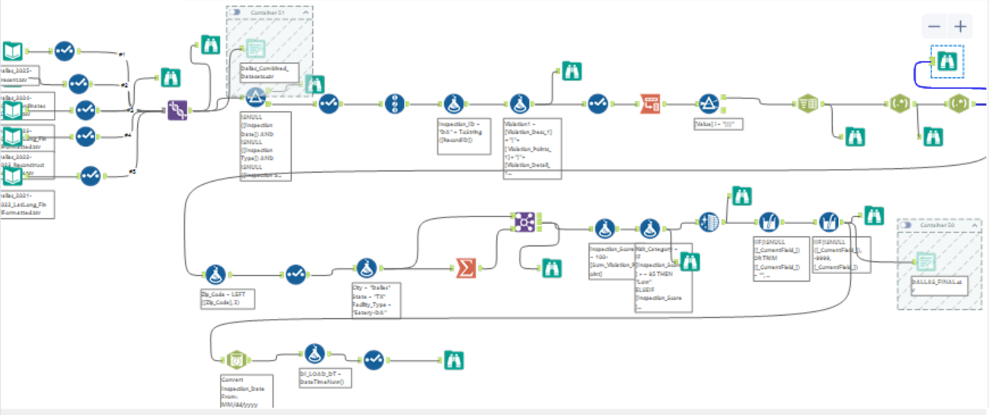
This is a detailed Alteryx workflow specifically designed to ingest, clean, normalize, and restructure the Dallas food inspection dataset. It takes wide-format raw data and prepares it for unified analysis.
- Input Tools (Top Left):
  - Reads five TSV files from different years (2021–2025).
  - Uses Select Tool to remove unneeded fields or fix data types early.
- Union Tool:
  - Combines all yearly files into one master dataset.
- Parse Violation Blocks:
  - Multiple Formula and Multi-Field Tools extract and reshape violations.
  - Only violations with non-null descriptions are retained.
- Address Normalization:
  - Merges address fields into a Full Address using Formula Tool.
  - Ensures Street Name, Type, Direction are merged logically.
- Latitude & Longitude Extraction:
  - Regex or Text-to-Columns separates coordinate pairs from the Lat Long Location field.
- ZIP Correction and Risk Mapping:
  - Joins ZIP data via a Join Tool.
  - Fills missing ZIPs and assigns Risk levels if necessary.
- Scoring Enhancements:
  - Uses Summarize Tool to group and calculate metrics like average violation scores.
  - Then re-joins summary data with cleaned dataset for enrichment.
- Final Output:
  - Writes to a structured DALLAS_FINAL.csv, ready for loading into staging.

- Dallas data is wide & inconsistent: workflow restructures it to a clean, analyzable format.
- Ensures that violation records are extractable and linked to inspection metadata.
- Efficient because only ~6 violation blocks are processed deeply, minimizing overhead on ~100 columns.
- Uses conditional logic to prevent unnecessary transformation for empty fields.
- Converts unusable wide-format data into a normalized dataset with 1 row per inspection or violation.
- Ready to be loaded into stg_dallas_inspections in Snowflake and visualized in dashboards.
2. Chicago Workflow:
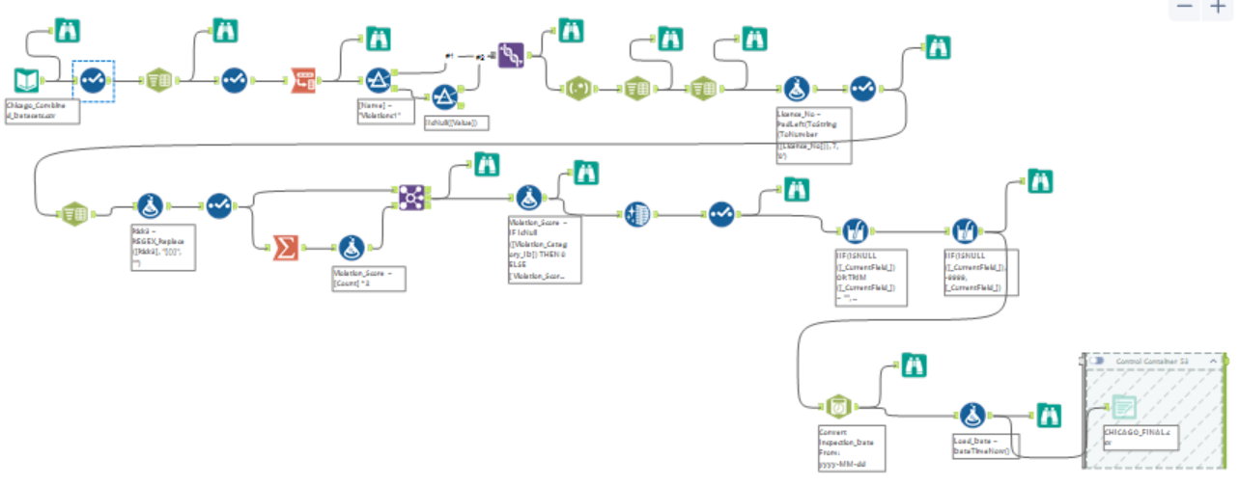
This workflow is for cleaning and parsing the Chicago food inspection data. Unlike Dallas, Chicago violations are stored as pipe-separated text in one column.
1. Input Tool:
- Reads multiple years of TSV files (2021–2025).
- Combines them via Union and standardizes field formats.
2. Violation Parsing:
- Uses Text-to-Columns Tool to split violations by |.
- Then uses Regex Tool to extract violation code and description.
3. Address and Location Fixes:
- Constructs Full Address using Address, City, State, ZIP.
- Fills missing State with 'IL' and City with 'CHICAGO'.
4. Geo Cleanup:
- Converts Latitude and Longitude to float types.
- Drops or flags rows with missing or invalid coordinates.
5. Score Enrichment:
- Extracts inferred scores from violation frequency or pattern matching.
- Summary metrics generated and joined using a Summarize Tool.
6. Final Output:
- Outputs cleaned file as CHICAGO_FINAL.csv.
- Transforms messy violation text into structured fields.
- Standardizes spatial and risk data for modeling.
- String parsing and regex are optimized using minimal branching.
- Uses containerization and filter logic to avoid redundant processing.
- Provides row-level, violation-level clarity.
- Enables 1-to-many relationship modeling for each inspection → multiple violations.
3. Combined Workflow:
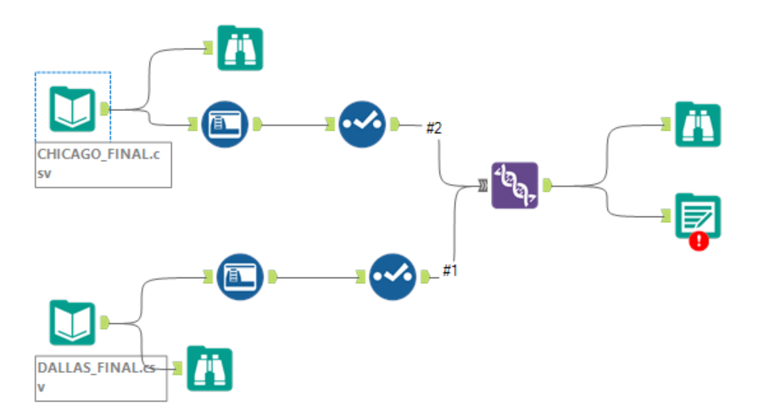
This smaller workflow shows the final joining of cleaned Dallas and Chicago datasets, forming the unified dataset used in downstream loading or visualization.
1. Input Tools:
- Reads in DALLAS_FINAL.csv and CHICAGO_FINAL.csv.
2. Data Profiling & Validation:
- Uses Browse Tools and Field Summary to inspect the schema.
- Ensures both datasets have the same fields and formats.
3. Join Tool (Purple DNA):
- Combines the two datasets into a single master output.
- Likely uses UNION or appends via row-binding.
4. Error Capture:
- Sends rejected rows (e.g., schema mismatches) to a separate branch with an Output with Warning/Error Tool.
- Lightweight, focused only on combining two already-cleaned datasets.
- Validation logic ensures no corrupted data flows into final output.

